PRESS RELEASE

May 8, 2013

KOFIA Publishes Domestic Fund Market Trend Analysis for April 2013

The NAV of total funds dropped by KRW 4.8tn from the previous month due to a decrease in MMFs, recording KRW 322.7tn.

- Overview

Despite an increase in bond funds, a decrease in MMFs caused the NAV of funds overall to drop by KRW 4.8tn MoM to record KRW 322.7tn, and the outstanding amount fell by KRW 3.9tn to post KRW331.7tn.

- (Increase in Bond Funds) The NAV of bond funds and hybrid-bond funds rose by KRW 4.8tn and KRW 1.3tn, respectively, due to increased capital inflow on the back of bargain hunting as bond yields temporarily rose* in early April.

*The 3-year corporate bond yield recorded 2.55% in early April (5th), rose up to 2.76%, and remained above 2.65% until April 24.

- In particular, domestic bond funds recorded a net inflow of KRW 0.9tn in April, driving the increase in the NAV of bond funds.

- (Decrease in MMFs) In April, MMFs decreased due to an outflow of capital, with institutional investors seeking redemptions, leading the NAV to drop by KRW 10.3tn from the previous month.

- VAT reports by institutional investors (companies closing accounts in December, reporting in April) and the increase* in direct bond purchases prompted by the momentary rise in bond yields, etc., are perceived to have driven institutional investors’ redemption of MMFs.

- Market Trends by Fund Type

- (Equity Funds) The KOSPI declined due to North Korea provocations and the weak performance of domestic companies, causing the NAV of equity funds to decrease. However, this was offset by the inflow of capital due to bargain hunting, so the NAV of equity funds edged down by KRW 0.05tn from the previous month to record KRW 64.4tn.

- Meanwhile, the continued redemption trend of overseas equity funds led the NAV and outstanding amount of overseas equity funds to drop by KRW 0.5tn MoM and KRW 0.8tn MoM correspondingly, reaching KRW 19.6tn and KRW 24.2tn, respectively.

- (Bond Funds) The NAV of domestic bond funds rose by KRW 4.5tn MoM to reach KRW 48.9tn, and the outstanding amount increased by KRW 4.7tn MoM to record KRW 48.3tn, driven by the inflow of capital due to bargain hunting following the temporary rise in bond yields in April 2013.

- The NAV of overseas bond funds persisted in its upward trend from March and increased by KRW 0.3tn MoM, reaching KRW 6.6tn, and the outstanding amount rose by KRW 0.3tn MoM, recording KRW 6.6tn.

- (MMFs) After a net outflow of KRW 2.0tn in March, MMFs continued to decrease in April due to institutional investors’ redemptions, and the NAV fell by KRW 10.3tn MoM to record KRW 66.0tn.

- (Derivatives Funds) The NAV of derivatives funds decreased by KRW1.3tn MoM to post KRW 31.6tn due to a decline in asset valuation.

- (Real Estate Funds) The NAV of real estate funds increased by KRW 0.32tn from the previous month to record KRW 20.7tn due to a net inflow of KRW 0.2tn.

- (Special Assets Funds) Driven by a net inflow of KRW 173bn, the NAV of special assets funds increased by KRW 165bn MoM to reach KRW 23.0tn.

- The NAV of other funds overall decreased slightly by KRW 57bn from the previous month to record KRW 85.58tn.

[NAV Changes and Fund Flow by Fund Type]
(Unit: KRW bn)
Fund Type | NAV  (End of Mar ’13) | Fund Flow |  |  | Valuation  Change | NAV  Change | NAV  (End of Mar ’13)
 |  | Inflow | Outflow | Change
Securities (A) | 165,507 | 9,859 | 6,855 | +3,004 | +2,602 | +5,606 | 171,113
- Equity | 84,621 | 2,655 | 2,385 | +270 | Δ 865 | Δ595 | 84,026
- Hybrid-Equity | 9,121 | 487 | 353 | +134 | Δ 67 | +67 | 9,188
- Hybrid-Bond | 21,128 | 2,414 | 885 | +1,529 | Δ 239 | +1,290 | 22,418
- Bond | 50,638 | 4,303 | 3,232 | +1,071 | +3,773 | +4,844 | 55,482
MMFs (B) | 76,322 | 35,597 | 46,057 | Δ10,460 | +160 | Δ10,300 | 66,022
Derivatives (C) | 32,859 | 2,485 | 1,177 | +1,308 | Δ 2,578 | Δ 1,270 | 31,589
Real Estate (D) | 20,383 | 470 | 273 | +197 | +127 | +324 | 20,707
Fund of Funds (E) | 9,591 | 1,138 | 528 | +610 | +114 | +724 | 10,315
Special Assets (F) | 22,801 | 371 | 198 | +173 | Δ8 | +165 | 22,966
Total  (A+B+C+D+E+F) | 327,464 | 49,920 | 55,088 | Δ 5,168 | +417 | Δ 4,751 | 322,713

Note: Valuation Change = NAV Change – Fund Flow Change
Securities = Equity + Hybrid Equity + Hybrid Bond + Bond
NAV includes ETFs, while fund flow data exclude ETFs.

- [Feature I] Growth of income funds led by overseas bond funds

The recent rise of income funds reflects market conditions that show a lack of an appropriate investment destination. Such trends are expected to continue for the time being due to uncertainties surrounding the stock market.

- (Growth of Income Funds) The AUM of income funds stood at merely KRW 566.6bn in 23 funds at the end of 2009, but has grown to KRW 2.5965tn in 67 funds as of April 25, 2013.

- (Background) Due to the low returns on equity funds amid stagnant conditions in the stock market at home and abroad, demand for investments in funds that generate stable profits prompted an increase in income fund investments.

- (Major Fund Types) In accordance with the nature of investments in income funds, which seek stable profits from interest and dividends, bond funds (36.8%), funds of funds (30.9%), and hybrid-bond funds (22.6%) account for approximately 90% of all income funds.

- (Domestic vs. Overseas Funds) Notably, most investments are made in overseas assets, such as emerging market bonds, and overseas investment funds account for 63.6% of overall income funds, while domestic investment funds make up 36.4%.

- (Public Placement vs. Private Placement) Investments in domestic income funds are far more concentrated in private placements, while public placements make up a larger portion of overseas income funds. Overall, private placements (56.3%) account for a larger proportion of funds than public placements (43.7%).

<No. of Funds and NAV Trends by Income Fund Type>

(Unit: KRW tn)

- (Asset Portfolio) Bond funds and funds of funds are the main assets, and bonds and beneficiary certificates account for 31.4% and 44.5%, respectively, from among overall income fund assets.

<Proportion of Public and Private Placement Income Funds (as of April 25, 2013)>

(Unit: KRW mn, %)
Category | Public Placement Funds | Proportion | Private Placement Funds | Proportion | Total
 | (a) | (a/c) | (b) | (b/c) | (c)
Domestic Investment Funds | 91,531 | 9.70% | 854,513 | 90.30% | 946,044
Overseas Investment Funds | 1,079,308 | 62.30% | 652,997 | 37.70% | 1,732,305
Total | 1,170,839 | 43.70% | 1,507,510 | 56.30% | 2,678,349

< Valuation by Income Fund Asset (as of April 25, 2013)>

(Unit: KRW mn, %)
Category | Equities | Bonds | Beneficiary Certificates | Liquid Assets | Others | Total
Domestic Investment Funds | 63,622 | 682,848 | 83,841 | 59,607 | 56,126 | 946,044
Overseas Investment Funds | 0 | 159,460 | 1,108,697 | 6,100 | 458,272 | 1,732,305
Total | 63,622 | 842,308 | 1,192,538 | 65,707 | 514,398 | 2,678,349
Proportion of Total Assets | 2.40% | 31.40% | 44.50% | 2.50% | 19.20% | 100.00%

[Feature II] Slow, Steady Growth of Real Estate Funds

The growth of real estate funds amid a downturn in the conditions of the real estate and construction markets is attributed to causes such as institutional investors seeking more alternative investments due to the bearish stock market.

- (Real Estate Funds) Despite the stagnant domestic real estate market and weak real estate project financing conditions over the past few years, the AUM of real estate funds grew to KRW20.7tn on the back of an increase in buy-lease real estate funds.

- (Causes of AUM Increase) The low returns for securities investment funds prompted increased investment in non-securities investment funds*, and views that the real estate market has hit a low is perceived to have boosted expectations.
* Real estate, derivatives, special asset funds, etc.

- Furthermore, despite the weak housing market, the relatively favorable profitability of the commercial real estate market also played a part in the increase in real estate funds.

- (Concentration in Buy-Lease Funds) From among the types of real estate fund investments*, buy-lease real estate funds have steadily increased since 2009, and account for the largest proportion of such funds (56%) as of April 25, 2013.

* Based on the types of real estate investments under the collective investment vehicle classification standards (development type, buy-lease type, PF loan type, REITs type, etc.)

- Meanwhile, the AUM of the PF loan type decreased, while the development and REITs types gained only slightly, showing a trend of investment concentration in buy-lease type real estate funds.

<AUM and Proportion by Real Estate Fund Type>
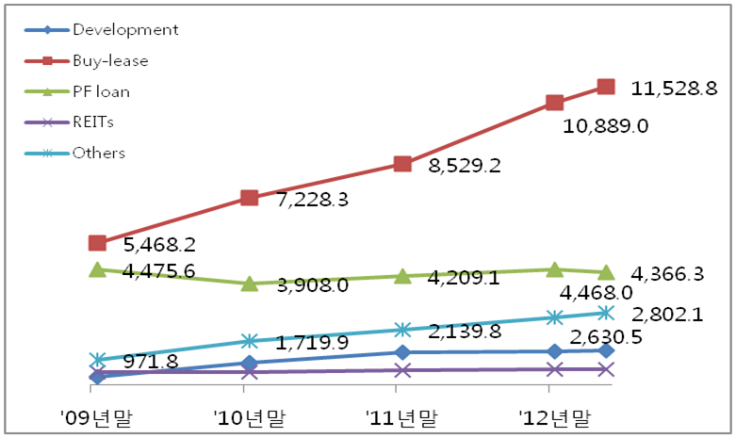
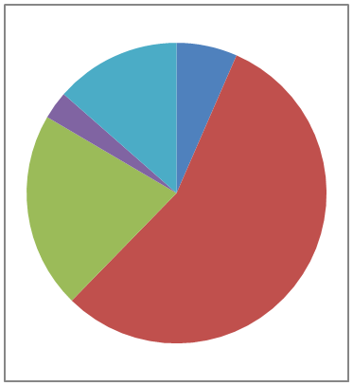
(Unit: KRW 10bn) (As of end-April, 2013)
REITs
3%
End of
Apr.’13
End of ‘12
End of ‘11
End of ‘09
End of ‘10
Development
6%
Others
14%
Buy-lease
56%
PF (loan)
21%
End of ‘09
End of ‘10
End of ‘11
End of ‘12

