추
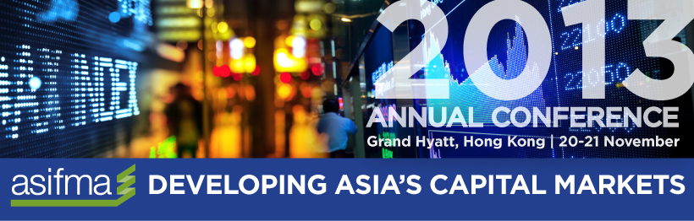

Dear KOFIA Members,

Asia Securities Industry & Financial Markets Association (ASIFMA) and KOFIA are pleased to invite you to the “ASIFMA Annual Conference 2013: Developing Asia’s Capital Markets,” hosted by ASIFMA. Please refer to the information below for details of the event:

Date: 20-21 Nov 2013
Venue: Grand Hyatt Hotel, Hong Kong
Registration fee: USD850/person for Members of KOFIA
(15% discount from original USD1,000)
* A complementary pass will be provided to the first regular member of KOFIA enrolling in the event.
JOIN NOW: Register here

For details and enrolment, click here for the event website. If you are interested to attend, please register online and confirmation email will be sent to you for successful registration.

For inquiry, please contact Michelle Cheung of ASIFMA at mcheung@asifma.org. Thank you.

Links: 1. Invitation to ASIFMA Annual Conference 2013

2. Event Website: http://www.asifma.org/annual2013/

